INSTRUCTIONS FOR BIAS – All Members

- Register your account by visiting www.ourbias.co.uk or by clicking the Members menu on the westmoorsbowls.club website and selecting Member Log in from the drop down menu
  - Click on Register in top right corner
  - Enter the email address that you already supplied to the club
  - Enter the password you would like to use and confirm that by entering it again
  - Click the Register button

- BIAS will now send an email to your email address and you need to click on the link in that email to confirm to the system that you have access to that email account. PLEASE NOTE: This email will be sent by admin@ourbias.co.uk – if you haven’t received an email within 5 minutes, please check in your SPAM/Junk folder in case your email client has intercepted it and incorrectly marked it as such. You will need to correctly identify emails from BIAS as ‘NOT JUNK’ in your email client. Normally achieved by right clicking on the email and marking it such. If you need any help with that, let us know.

- Go back to www.ourbias.co.uk or click the Members menu on the westmoorsbowls.club website and Log into the system using the button in the top right corner using your email address and the password you just set. PLEASE NOTE: Passwords are case sensitive

- Once logged in you will see various drop-down menus at the top of the screen.

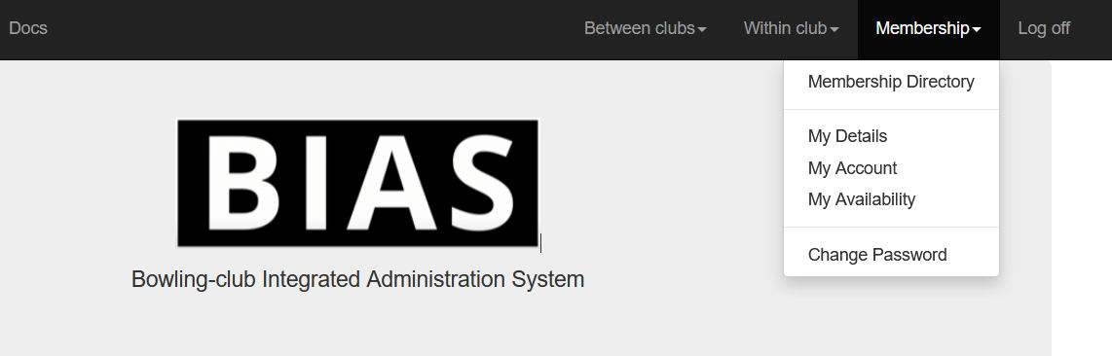

  - MEMBERSHIP
    - Clicking on Membership Directory will show other members contact information if needed when organising matches etc. Basically an electronic version of the usual tri-fold leaflet produced by the club each year.

    - Clicking on My Details shows your contact details – please check to make sure that your address and telephone numbers are correct. You can overtype these fields and then click SAVE at the bottom to update the info. There is no need to enter any further information such as birthday, or car information – these fields are not used

by our club. PLEASE DO NOT ENTER EMAIL INFORMATION IN EITHER OF THE EMAIL FIELDS. In the event that you should change your email address, please contact the Membership Secretary.

    - MY ACCOUNT & MY AVAILABILITY ARE NOT USED AT THIS TIME

  - WITHIN CLUB
    - League Teams and League options are not being used at this time
    - Knockout teams aren’t in use at this time
    - Knockout Competitions will display the internal competitions for the season
PLEASE DO NOT CLICK APPLY ON ANY OF THESE COMPETITIONS – if you have already entered the competitions, your name should appear when viewing ‘ENTRANTS’ against the relevant competition

    - RINK CALENDAR – this will take you to the online rink booking system. The club rules surrounding booking a rink still apply – ie, booking a rink for casual play or roll ups are NOT PERMITTED

To book a rink when you have a match arranged, firstly select the date you wish to book the rink for. Clicking on the … next to the date shown will drop down a calendar for you to use. Scroll down the screen until you see the Rink Booking Grid where any available rink is shown in green.
Click in one of the rinks at the preferred time and this will open up a new screen and show an area where you can input the description of your booking. For example Joe Bloggs v Richard Anyone – Men’s Singles Once you have completed your description, click on the Reserve Link button. Please ignore the blue arrow that appears by default and read below.
NOTE: BOOKING A RINK IS NOT BOOKING A SPECIFIC RINK NUMBER FOR YOUR MATCH – MERELY RESERVING ONE OF THE AVAILABLE RINKS ON ANY GIVEN DAY. In other words, booking rink 5 is only reserving a rink, it does not mean that you will have exclusive availability of that rink number for your match. The rink you play on should be agreed before the start of your match in the usual way.

When you have completed your booking, you will notice that your booking and any others you have made will appear at the bottom of the screen. If you need to cancel any or all of your bookings, simply click the box to the left of it and then click the Cancel ticked reservations button and this will then clear your booking.
You can book a rink remotely, or use the computer that is now available in the office. The diary will be removed, so rinks can only be booked on the BIAS system – equally, you will only be able to review rink availability online.
If in any doubt about booking a rink or are unable to complete your booking, please call either David Rose, Mike Dorman, Dave Oakes or Simon Smale. At the start of the season these people are designated ‘administrators’ of the booking system.

C) BETWEEN CLUBS
- Leagues and friendlies – clicking on this link will show you all the various leagues our club will be playing in this season. Selecting ‘VIEW’ on a specific league will show you the basic set up of this league and it’s associated matches.

Selecting ‘GAMES’ will show a lists of all of the games and the dates that all matches are due to be played within the league selected.

While in this section, clicking on ‘PLAYERS’ will show the names of members selected for any given match. This content of this page will change according to input by the selectors when they are in the process of putting the teams together.

- Games – Clicking on this link will show ALL WMMBC fixtures for the next 30 days. If you want to view ALL fixtures for the whole season, simply click on the ‘Show All Games to end of Season’ button. This will then display ALL WMMBC fixtures for the whole season.

PLEASE DO NOT CLICK ON THE APPLY BUTTON FOR ANY MATCHES!

FOR ALL MEMBERS WITH AN EMAIL ADDRESS Our Captains & Selectors have made the decision that for this season, we will continue to use the existing system of advising when you are unavailable to be considered for selection for any given match. You will continue to be required to complete the forms available in the club house for this purpose ie: cross out any dates that you are unavailable.
At their normal selection meeting each week, the selectors will make their choices for members to play for each team using these sheets as previously, so there is no need to click on the APPLY button for any game that you wished to be considered for.

Where the BIAS system has been implemented and will consequently help us all through the season, is that once the selectors have chosen you to play in a match, the system will advise you as follows:
- You will receive an email to notify you that you have been selected to play, against which team and in which league AND the time the match will start. If you want to accept your selection and confirm that you want to play, all you need to do is simply reply to that email. The instructions on how to confirm your selection will also appear on the emai
- If you are unable to play, simply ignore the email – DO NOT REPLY TO DECLINE THE INVITATION – your reply will go to an unmonitored mail box.
- Replying to the email will generate a confirmation for the selectors that you have accepted their invitation to play in the match concerned.
- You will receive a further email from the system to confirm that you have accepted selection and more details about the match and in particular the venue, the start time and for an away match, what time we are intending to leave the club. The email will also include the match Captain’s telephone numbers – IF YOU ARE UNABLE TO PLAY FOR ANY REASON, YOU MUST TELEPHONE THEM TO LET THEM KNOW!
- The day before the match is due to be played, you will receive a further email to remind you that you are due to represent the club the following day.
MEMBERS WITHOUT EMAIL ADDRESSES must continue to visit the changing rooms to check to see if they have been selected for a match and tick the appropriate form to confirm their intention to play for this season. NO REMINDERS WILL BE GIVEN TO MEMBERS SELECTED TO PLAY.
- Rink Calendar - will take you to the same Rink Booking screen explained above.
- Past Games - is not being used this season, but would normally allow you to see the results of previous matches.
- View Another Club’s Details – this feature isn’t currently in use
- Export Season’s Games – generates a CSV file of all games in the season

David Rose - March 2024

